**SQL Lesson 1: SELECT queries**

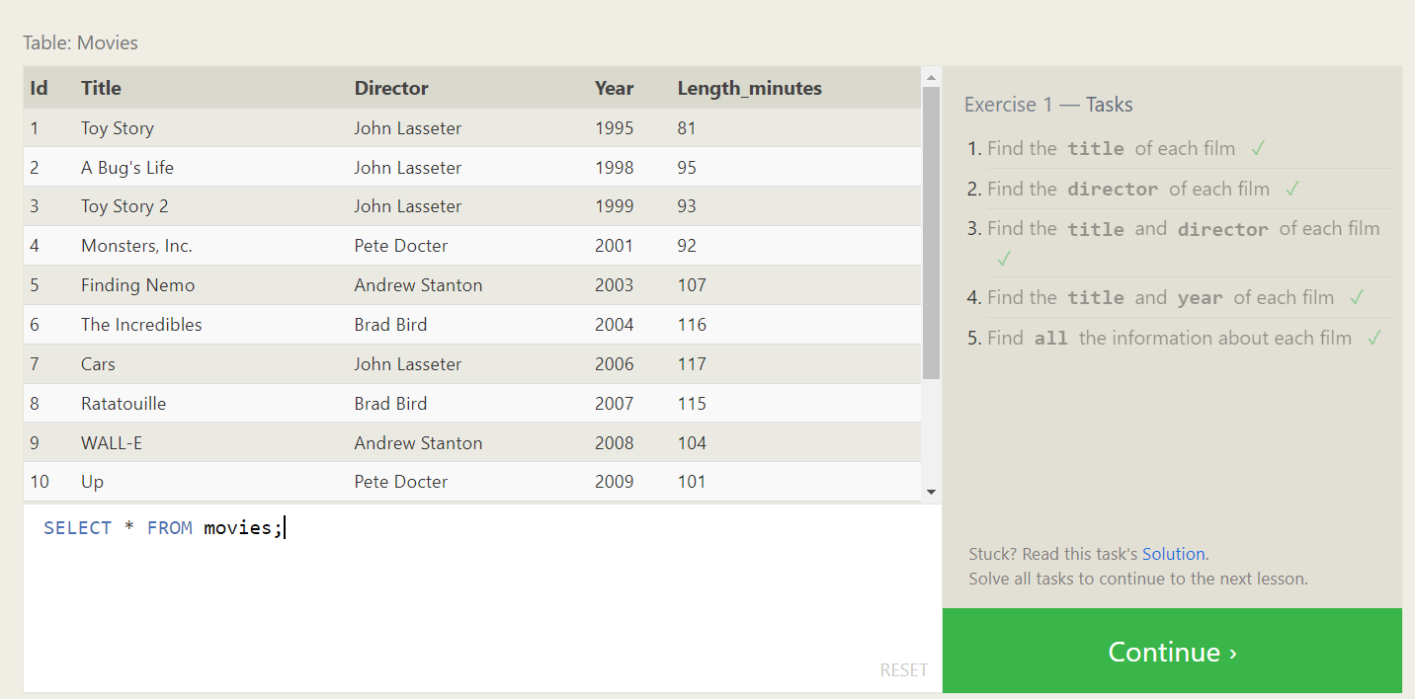

1. SELECT Title FROM movies;
2. SELECT Director FROM movies;
3. SELECT Title, Director FROM movies;
4. SELECT Title, year FROM movies;
5. SELECT * FROM movies;

**SQL Lesson 2: Queries with constraints**

1. SELECT * FROM movies

WHERE ID = 6;

2. SELECT * FROM movies

WHERE year BETWEEN 2000 AND 2010;

3. SELECT * FROM movies

WHERE year NOT BETWEEN 2000 AND 2010;

4. SELECT Title, Year FROM movies

WHERE Director IN ('John Lasseter', 'Andrew Stanton', 'Brad Bird', 'Pete Docter', 'Lee Unkrich')

ORDER BY Year

LIMIT 5;

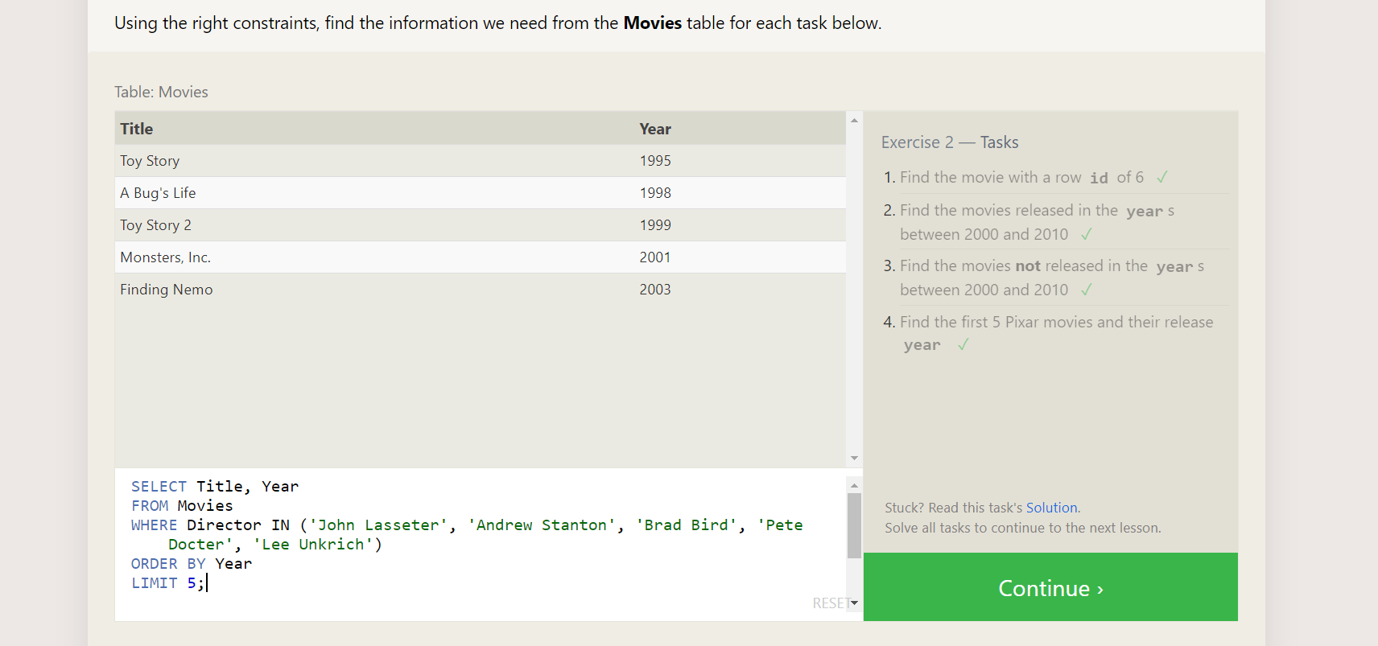

**SQL Lesson 3: Queries with constraints**

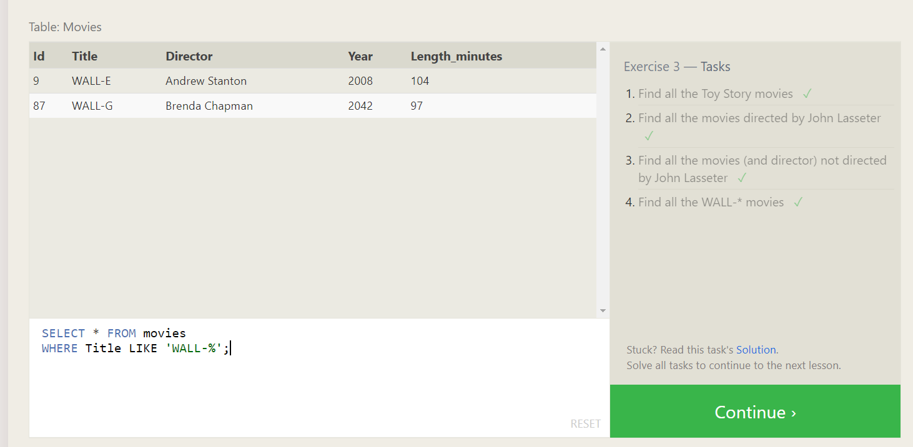

1. SELECT * FROM movies

WHERE Title LIKE 'Toy Story%';

2. SELECT * FROM movies

WHERE director LIKE 'John Lasseter%';

3. SELECT * FROM movies

WHERE director NOT LIKE 'John Lasseter%';

4. SELECT * FROM movies

WHERE Title LIKE 'WALL-%';

**SQL Lesson 4: Filtering and sorting Query results**

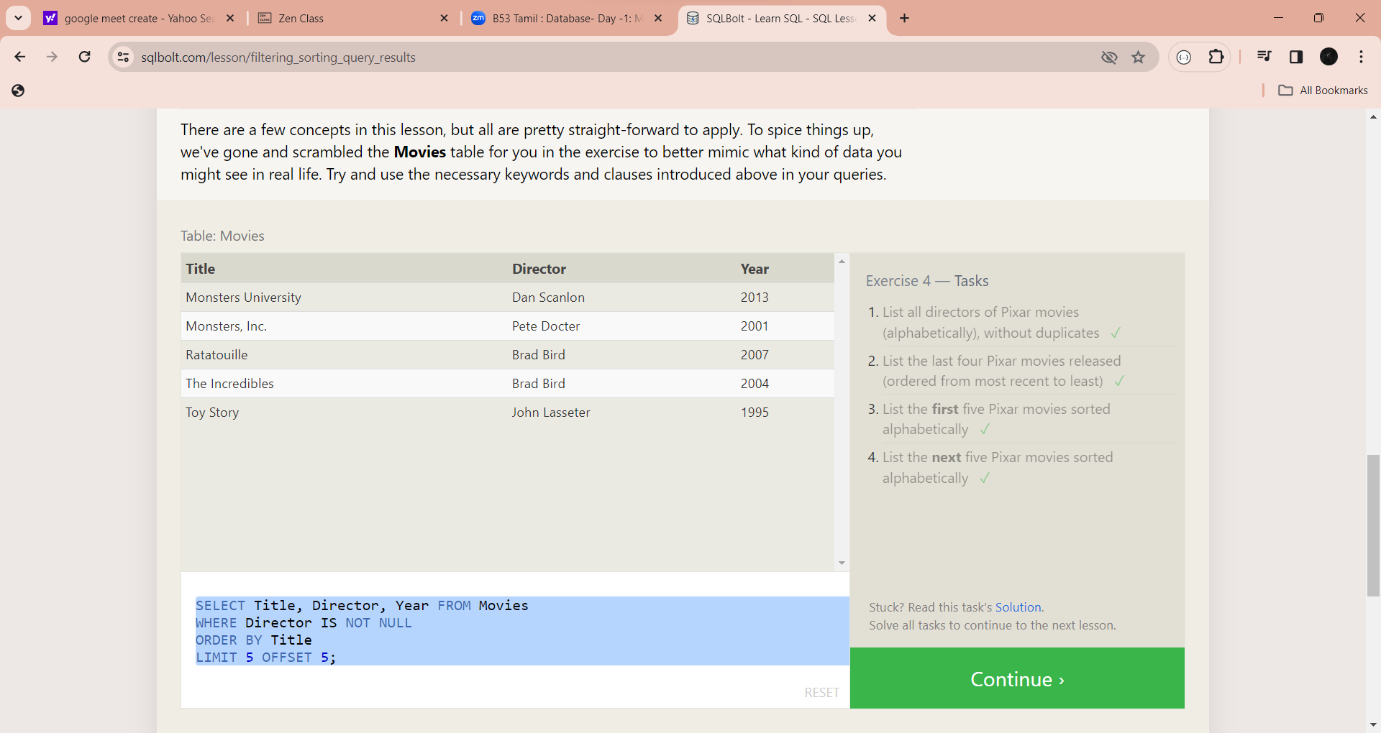

1. SELECT DISTINCT Director FROM Movies

WHERE Director IS NOT NULL

ORDER BY Director;

2. SELECT Title, Year FROM Movies

WHERE Director IS NOT NULL

ORDER BY Year DESC

LIMIT 4;

3. SELECT Title, Director, Year FROM Movies

WHERE Director IS NOT NULL

ORDER BY Title

LIMIT 5;

4. SELECT Title, Director, Year FROM Movies

WHERE Director IS NOT NULL

ORDER BY Title

LIMIT 5 OFFSET 5;

**SQL Review 5 : Simple SELECT Queries**

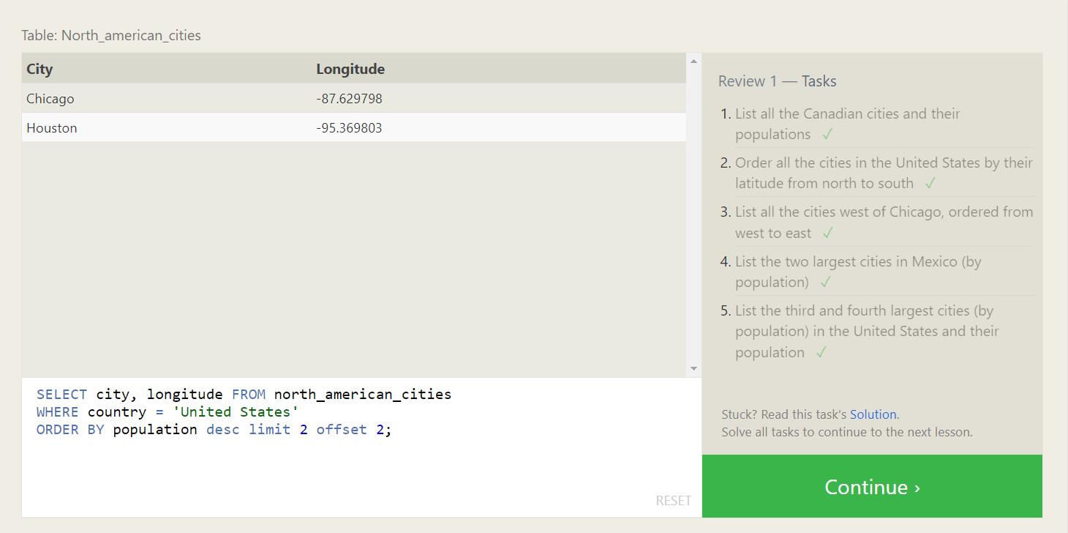

**SQL Lesson 6: Multi-table queries with JOINs**

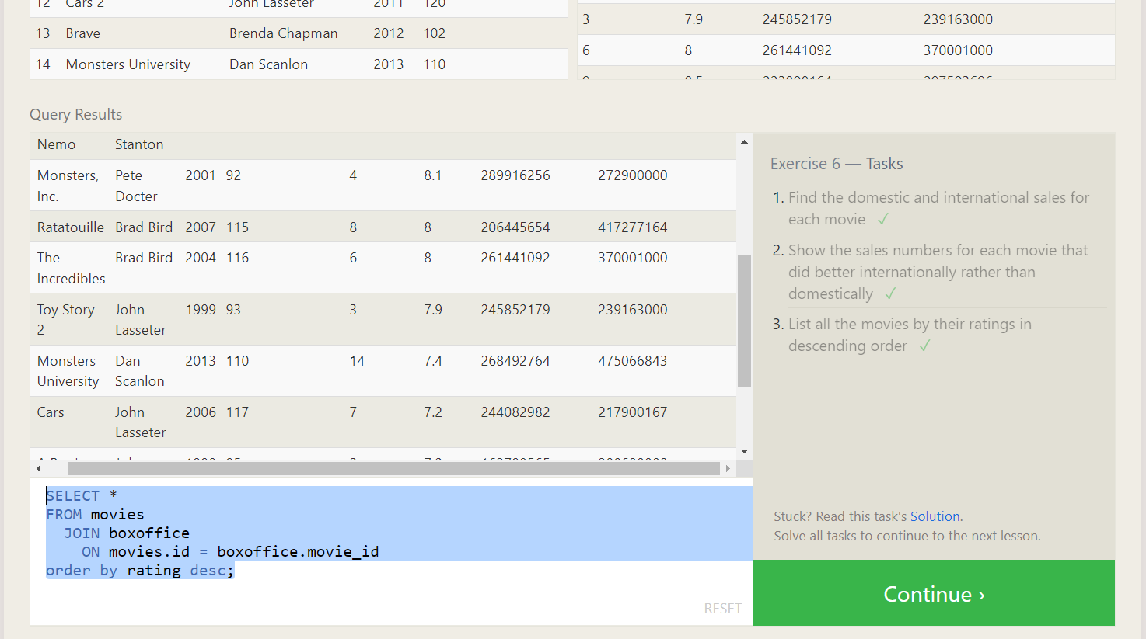

1. SELECT title, domestic_sales, international_sales

FROM movies

JOIN boxoffice

ON movies.id = boxoffice.movie_id;

2. SELECT title, domestic_sales, international_sales

FROM movies JOIN boxoffice ON movies.id = boxoffice.movie_id

WHERE international_sales > domestic_sales;

3. SELECT *FROM movies JOIN boxoffice ON movies.id = boxoffice.movie_id order by rating desc;

**SQL Lesson 7: OUTER JOINs**

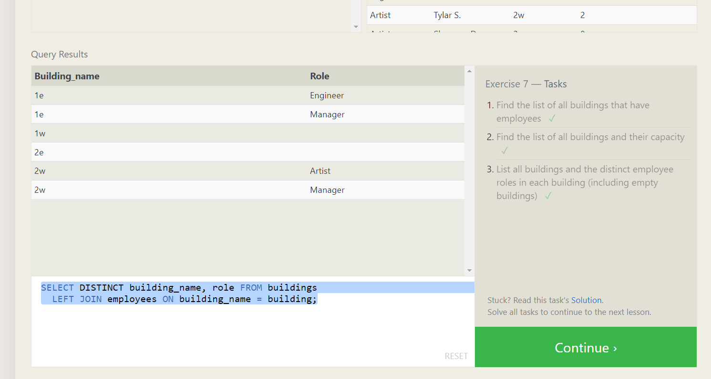

1. **SELECT DISTINCT building FROM employees;**
2. **SELECT * FROM buildings;**
3. **SELECT DISTINCT building_name, role FROM buildings**

**LEFT JOIN employees ON building_name = building;**

**SQL Lesson 8: A short note on NULLs**

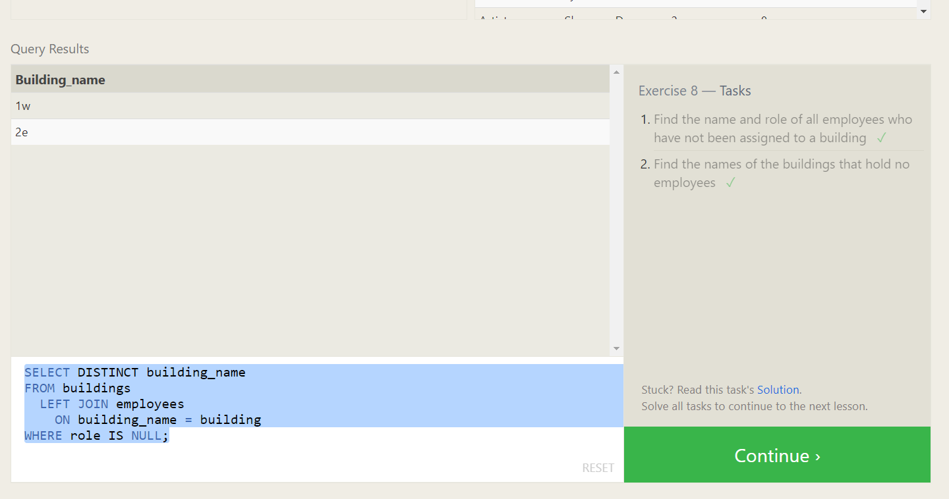

**1.** **SELECT name, role FROM employees**

**WHERE building IS NULL;**

**2. SELECT DISTINCT building_name FROM buildings**

**LEFT JOIN employees ON building_name = building**

**WHERE role IS NULL;**

**SQL Lesson 9: Queries with expressions**

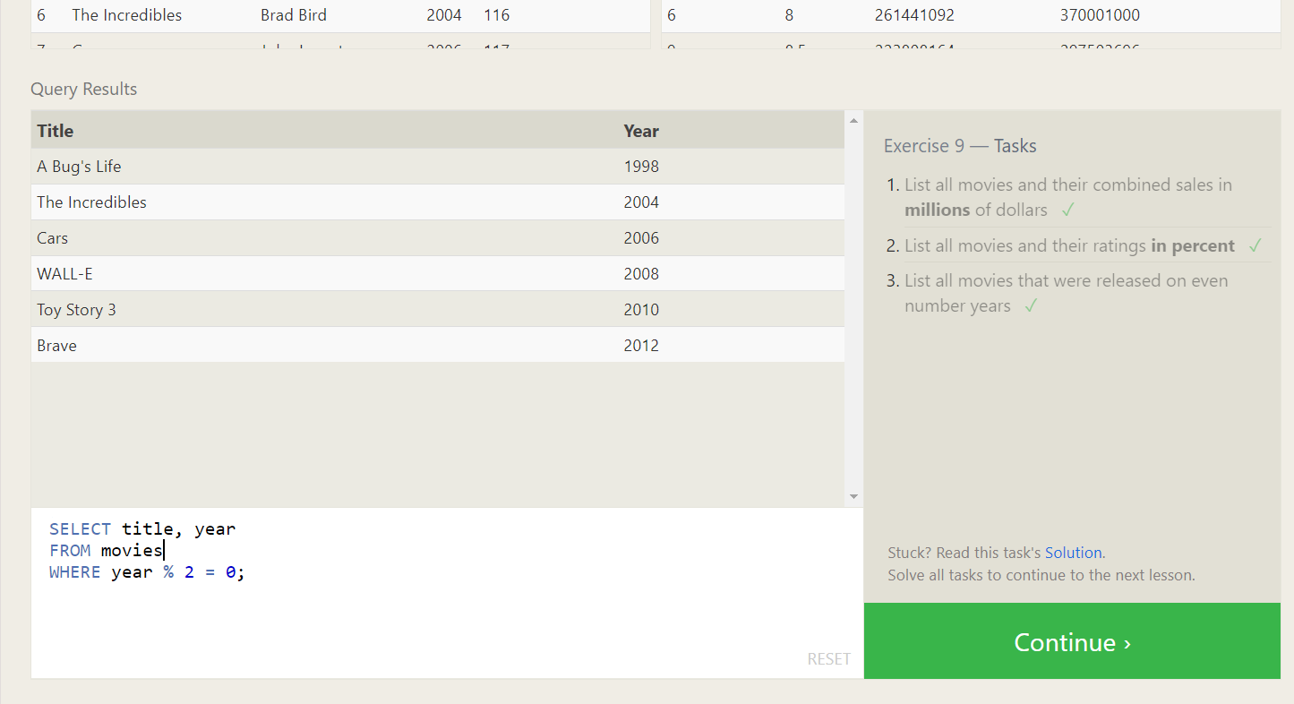**1.** **SELECT title, (domestic_sales + international_sales) / 1000000 AS gross_sales_millions**

**FROM movies**

**JOIN boxoffice**

**ON movies.id = boxoffice.movie_id;**

**2.** **SELECT title, rating * 10 AS rating_percent**

**FROM movies**

**JOIN boxoffice**

**ON movies.id = boxoffice.movie_id;**

**3.** **SELECT title, year**

**FROM movies**

**WHERE year % 2 = 0;**

**SQL Lesson 10: Queries with aggregates (Pt. 1)**

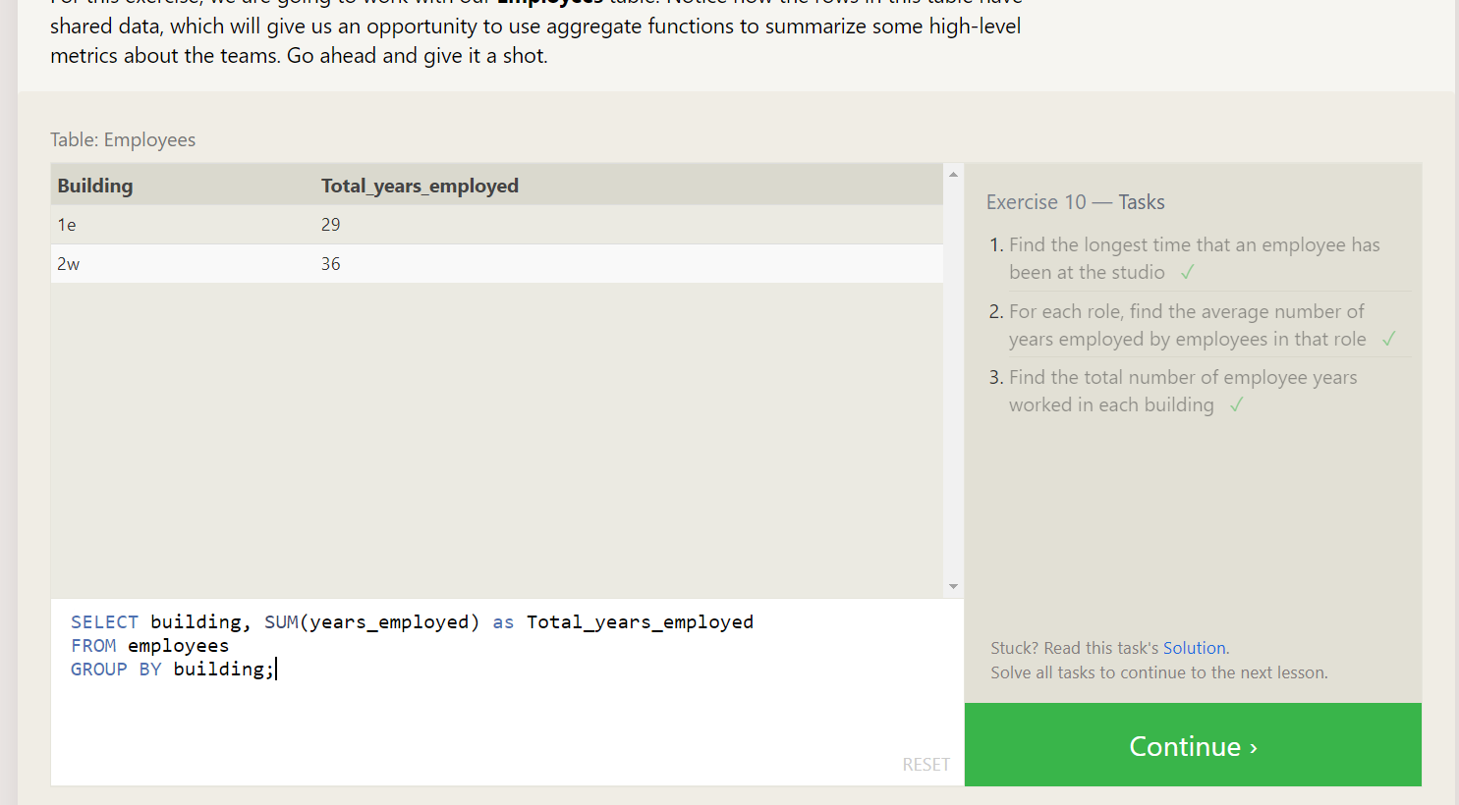

**1.** **SELECT MAX(years_employed) as Max_years_employed**

**FROM employees;**

**2.** **SELECT role, AVG(years_employed) as Average_years_employed**

**FROM employees**

**GROUP BY role;**

**3.** **SELECT building, SUM(years_employed) as Total_years_employed**

**FROM employees**

**GROUP BY building;**

**SQL Lesson 11: Queries with aggregates**

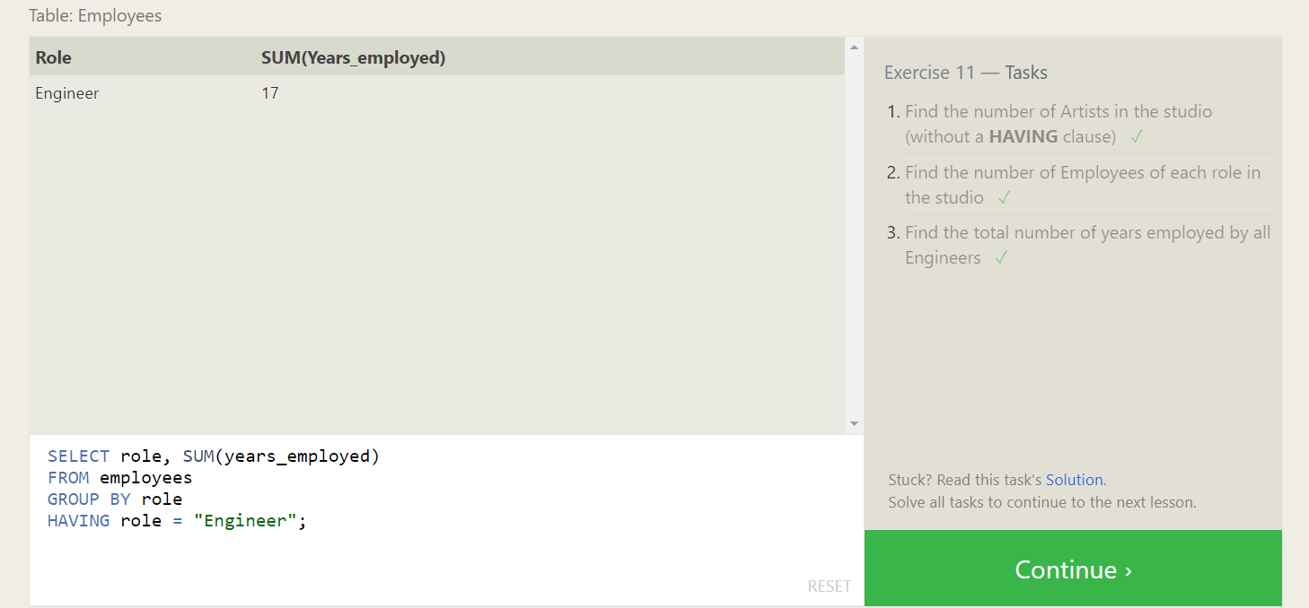

**1.** **SELECT role, COUNT(*) as Number_of_artists**

**FROM employees**

**WHERE role = "Artist";**

**2.** **SELECT role, COUNT(*)**

**FROM employees**

**GROUP BY role;**

**3.** **SELECT role, SUM(years_employed)**

**FROM employees**

**GROUP BY role**

**HAVING role = "Engineer";**

**SQL Lesson 12: Order of execution of a Query**

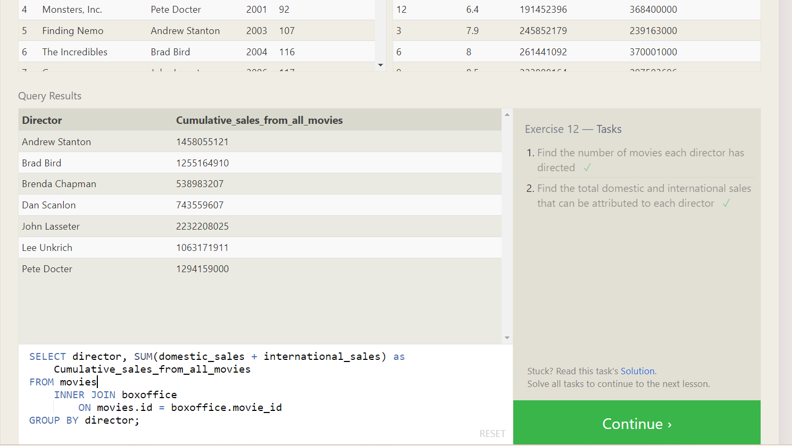

**1.** **SELECT director, COUNT(id) as Num_movies_directed**

**FROM movies**

**GROUP BY director;**

**2.** **SELECT director, SUM(domestic_sales + international_sales) as Cumulative_sales_from_all_movies**

**FROM movies**

**INNER JOIN boxoffice**

**ON movies.id = boxoffice.movie_id**

**GROUP BY director;**

**SQL Lesson 13: Inserting rows**

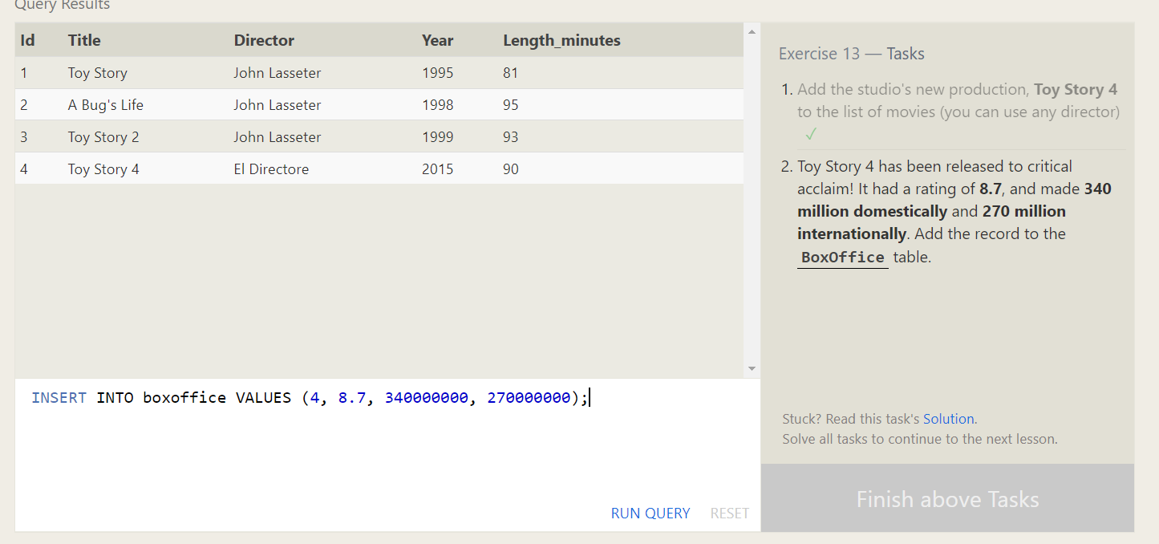

1. **INSERT INTO movies VALUES (4, "Toy Story 4", "El Directore", 2015, 90);**
2. INSERT INTO boxoffice VALUES (4, 8.7, 340000000, 270000000);

**SQL Lesson 14: Updating rows**

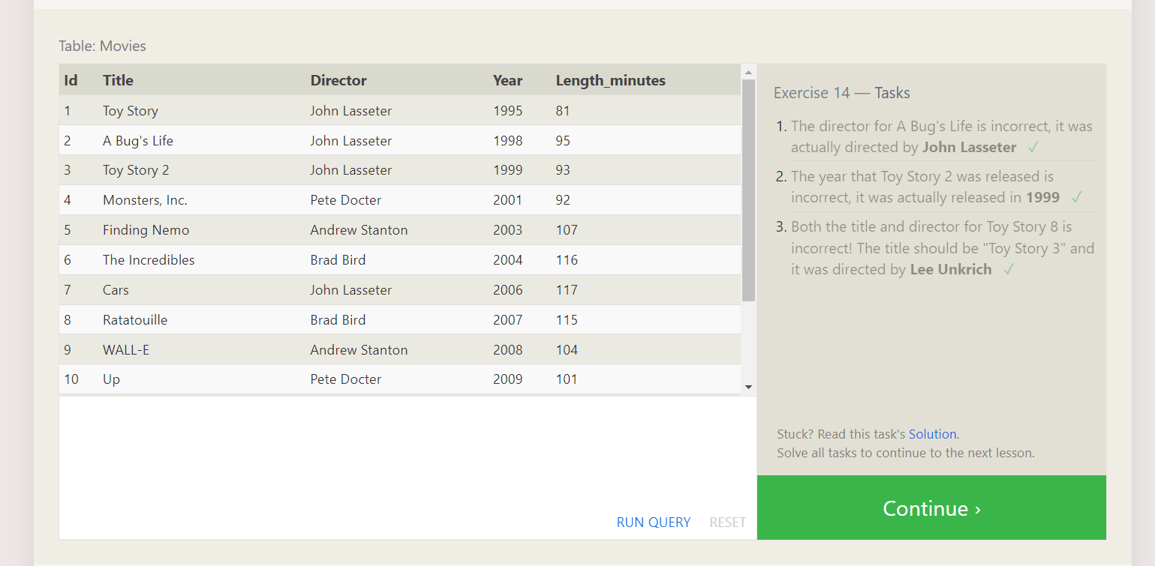

1. UPDATE movies

SET director = "John Lasseter"

WHERE id = 2;

2. UPDATE movies

SET year = 1999

WHERE id = 3;

3. UPDATE movies

SET title = "Toy Story 3", director = "Lee Unkrich"

WHERE id = 11;

**SQL Lesson 15: Deleting rows**

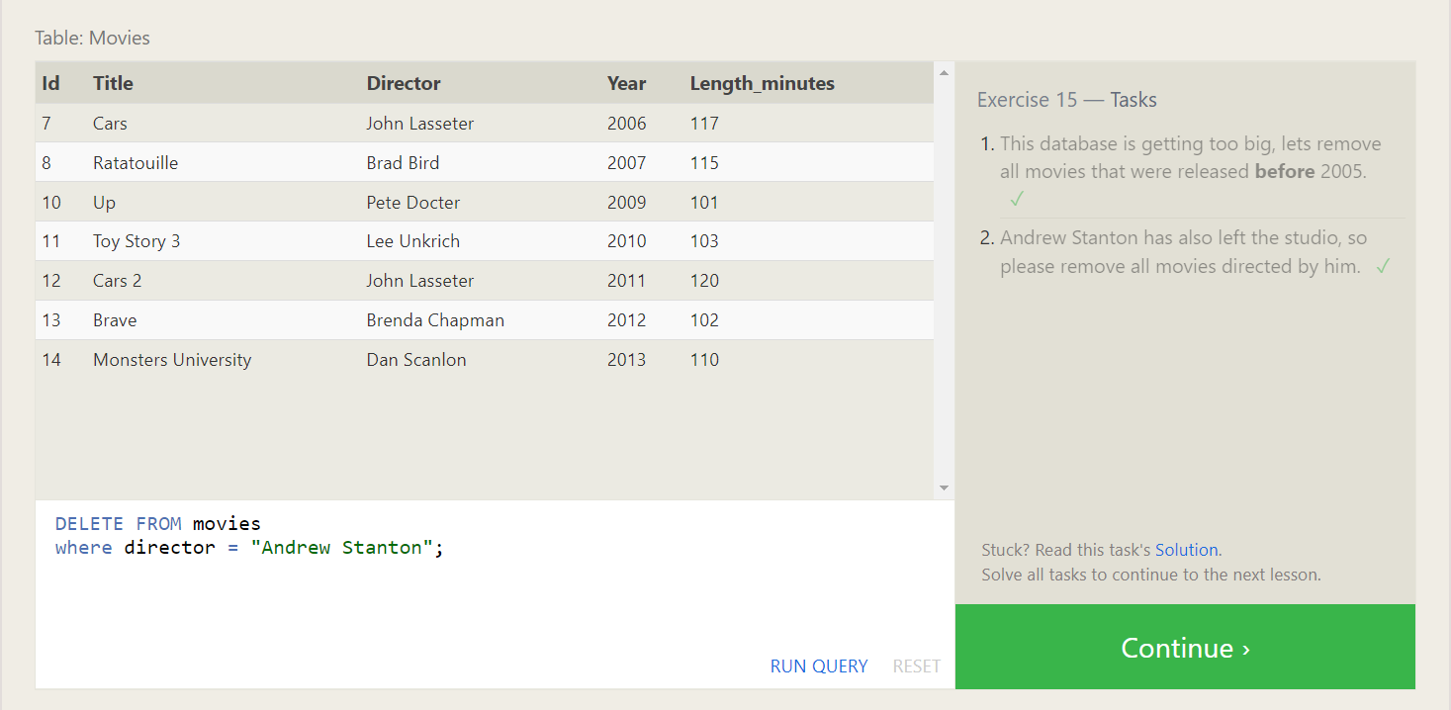

1. DELETE FROM movies

where year < 2005;

1. DELETE FROM movies

where director = "Andrew Stanton";

**SQL Lesson 16: Creating tables**

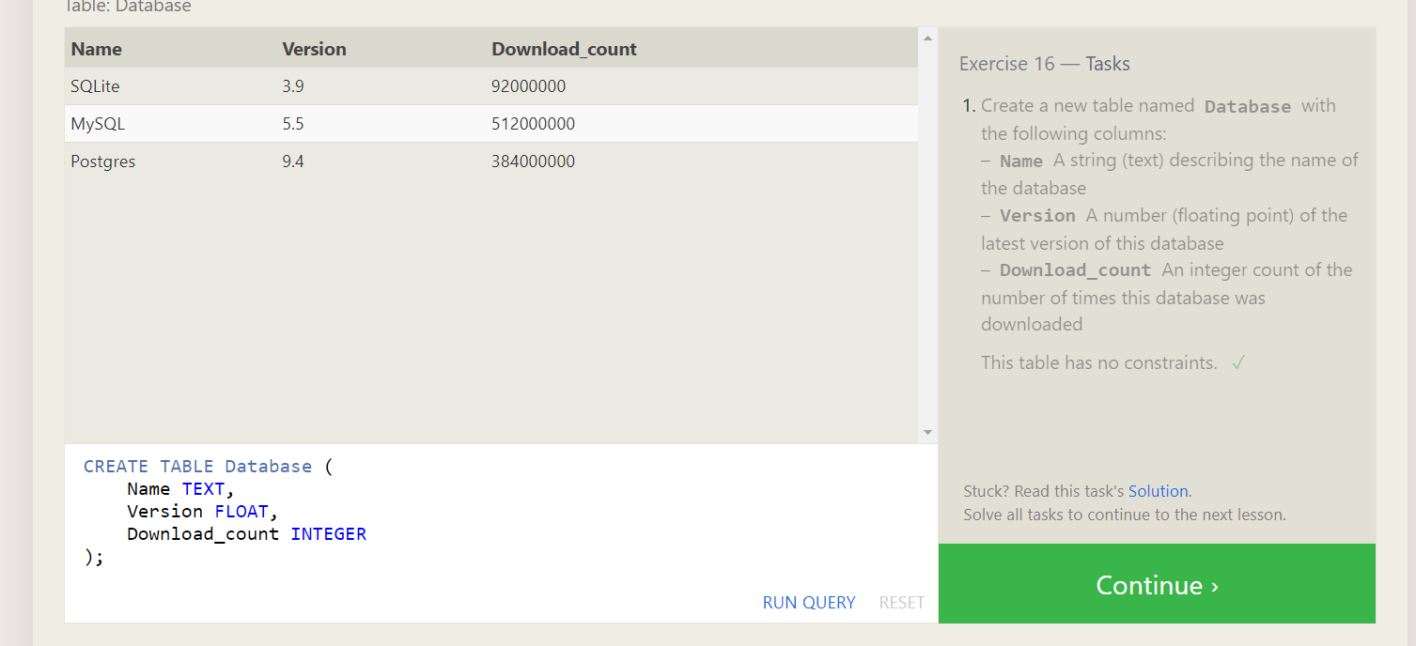

CREATE TABLE Database (

Name TEXT,

Version FLOAT,

Download_count INTEGER

);

**SQL Lesson 17: Altering tables**

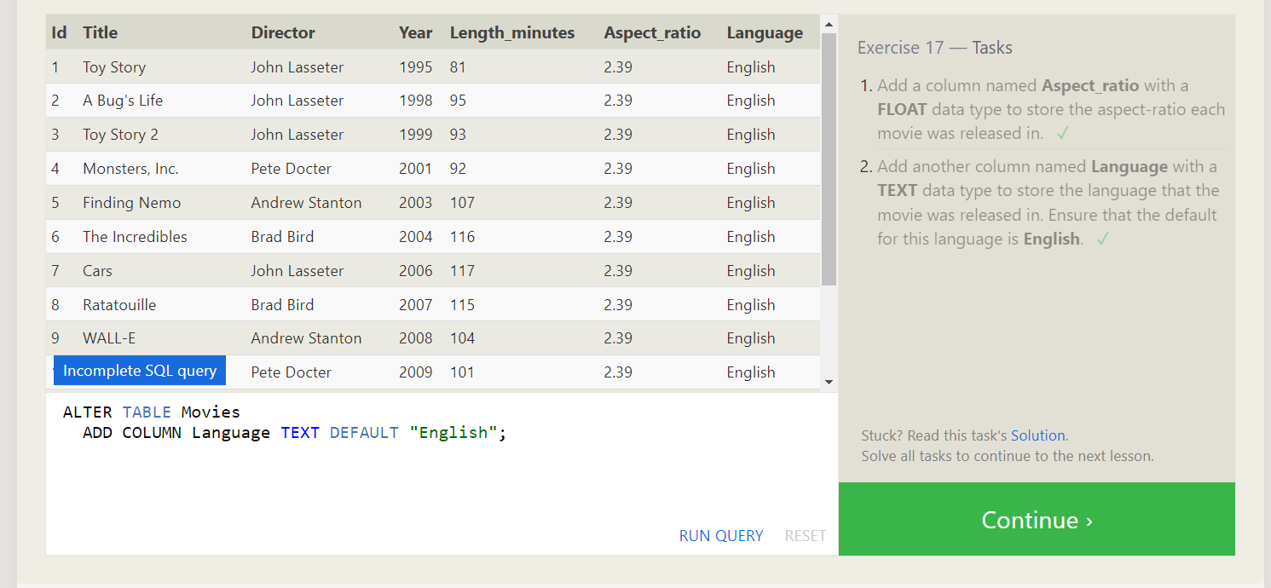

1. ALTER TABLE Movies

ADD COLUMN Aspect_ratio FLOAT DEFAULT 2.39;

1. ALTER TABLE Movies

ADD COLUMN Language TEXT DEFAULT "English";

**SQL Lesson 18: Dropping tables**

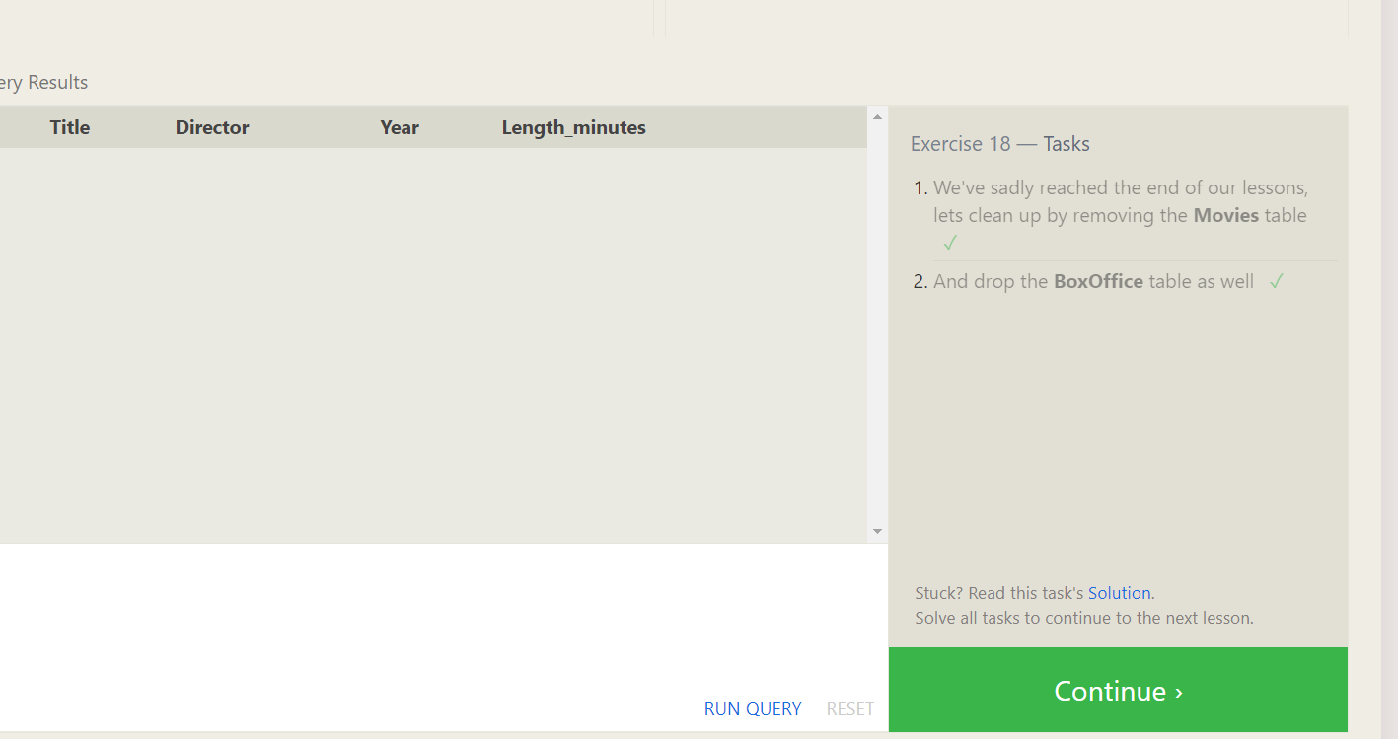

1. DROP TABLE Movies;
2. DROP TABLE BoxOffice;

